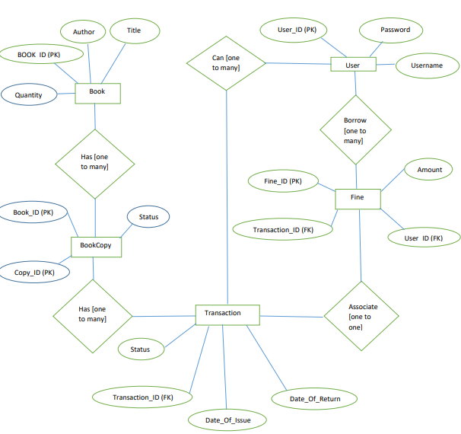

**Admin Table:-**

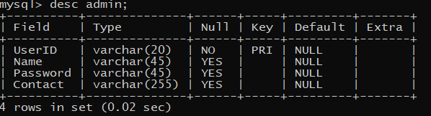

**Book Table:-**

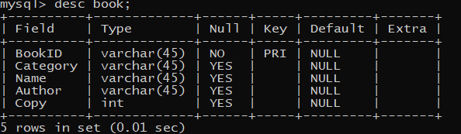

**Staff table:-**

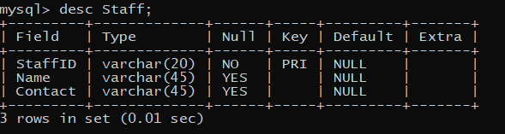

**Librarian table:-**

